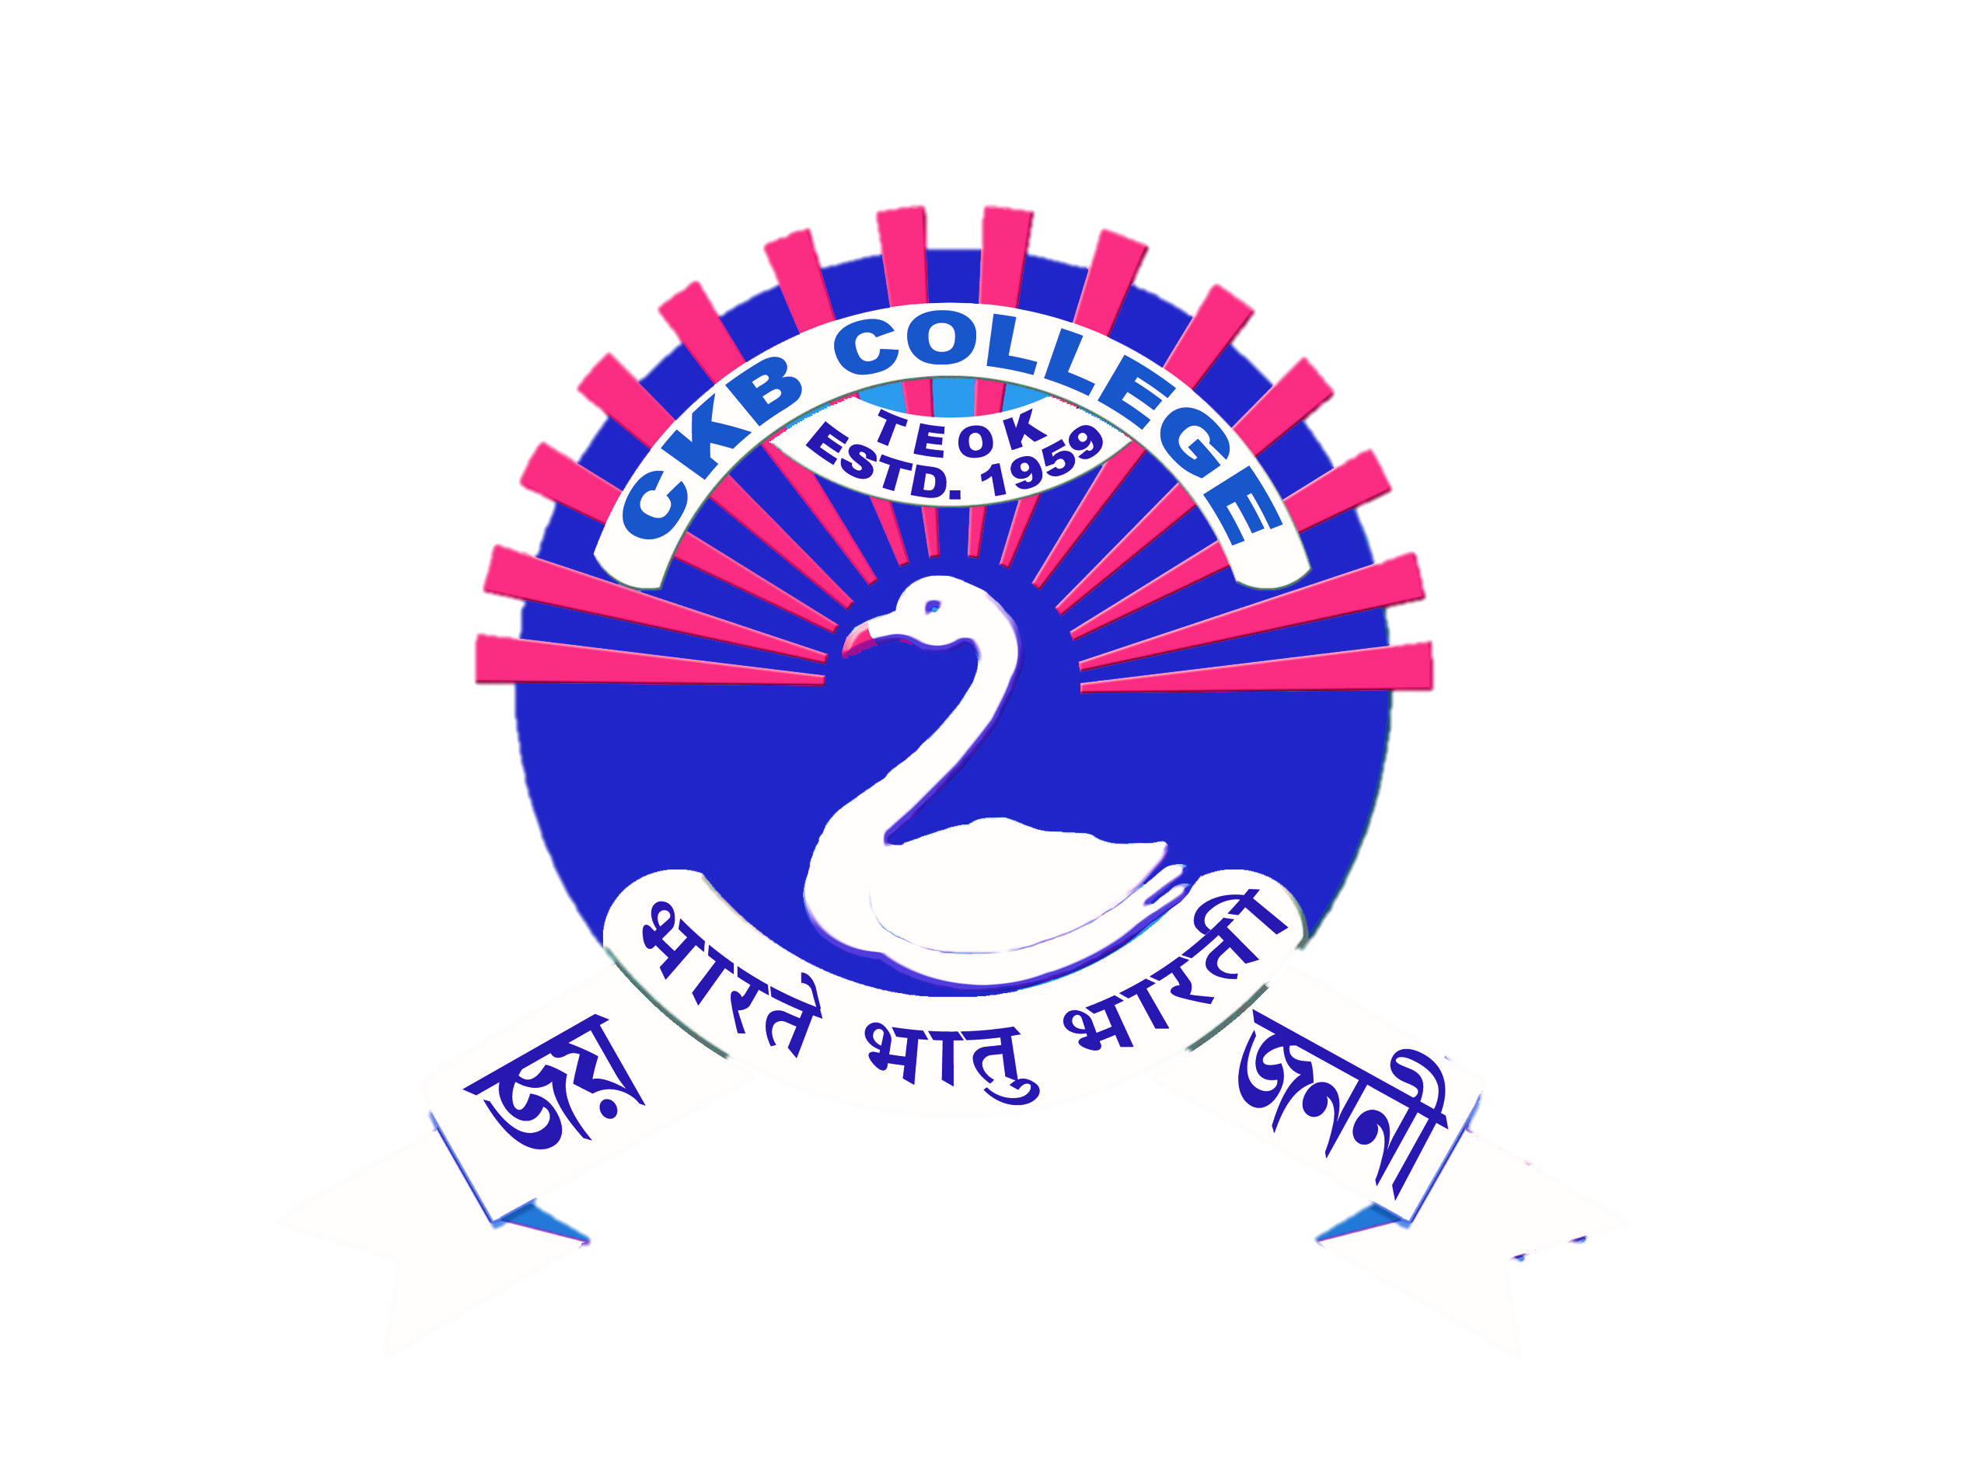

**CHANDRA KAMAL BEZBARUAH COLLEGE, TEOK**

**চন্দ্ৰকমল বেজবৰুৱা মহাবিদ্যালয়, টীয়ক**

**(Affiliated to Dibrugarh University, Assam )**

|  |
| --- |
| List of faculty members authenticated by the Head of the Institution |
| Year 2021-2022 |
| Total Teacher Members: 34 |

|  |
| --- |
| List of faculty members authenticated by the Head of the Institution |
| Year 2020-2021 |
| Total Teacher Members: 35 |

|  |
| --- |
| List of faculty members authenticated by the Head of the Institution |
| Year 2019-2020 |
| Total Teacher Members: 30 |

|  |
| --- |
| List of faculty members authenticated by the Head of the Institution |
| Year 2018-2019 |
| Total Teacher Members: 33 |

|  |
| --- |
| List of faculty members authenticated by the Head of the Institution |
| Year 2017-2018 |
| Total Teacher Members: 34 |