7.1.2 - C.K.B. College, Teok uses LED Bulbs, has solar panels and censor light at the campus as alternate sources of energy and energy conservation measures-

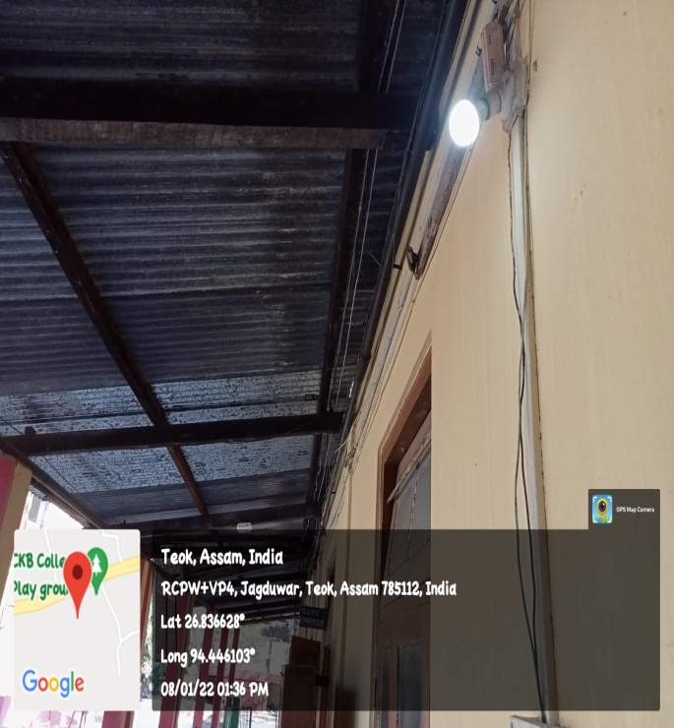 | 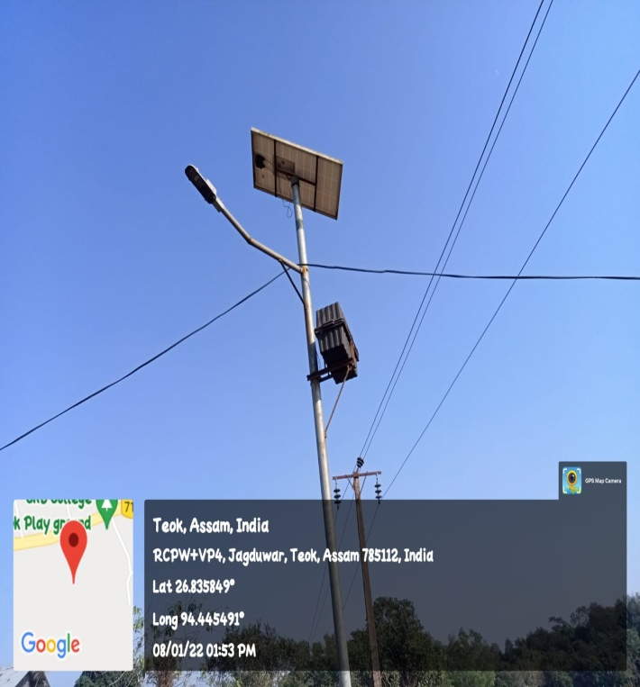
USE OF LED BULBS | SOLAR ENERGY
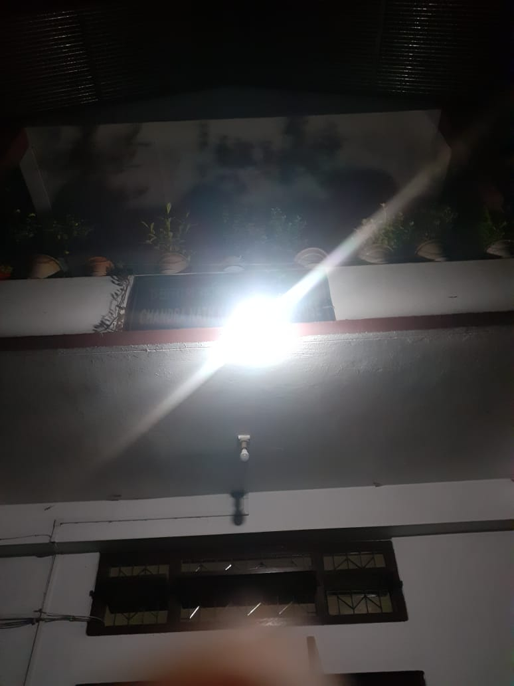

SENSOR-BASED LIGHT

