SPECIFIC FACILITIES AVAILABLE FOR WOMEN IN TERMS OF SAFETY AND SECURITY, COUNSELING, COMMON ROOM, DAY CARE AND ANY OTHER
The institution takes utmost initiatives for overall protection and development of girls’ student on the campus. To support these initiatives, there are some special facilities such as placement of CCTV Camera at corridors, counseling room, girls’ common room, incinerator, distribution of sanitary napkins and day-care room provided to the girl students and female staff of the institution.
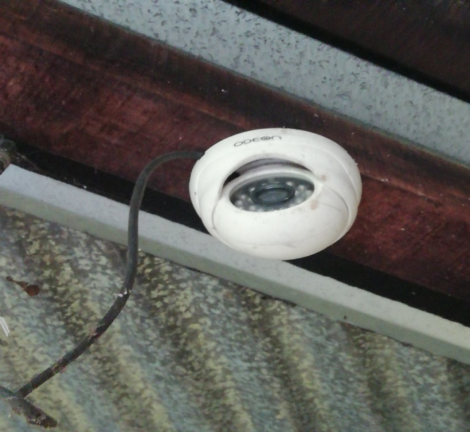  - CCTV CAMERA | 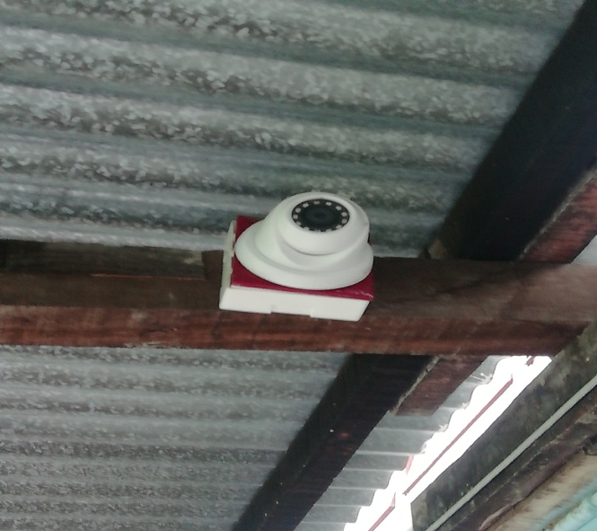  - CCTV CAMERA
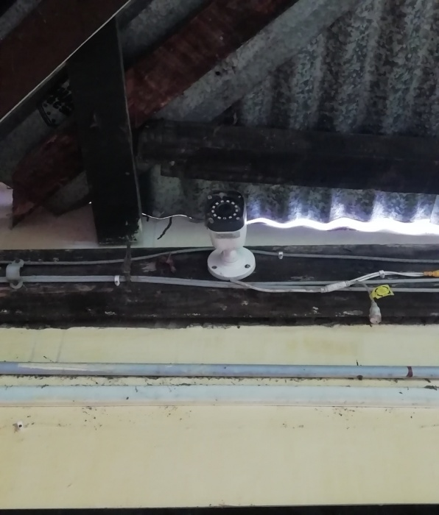  - CCTV CAMERA | 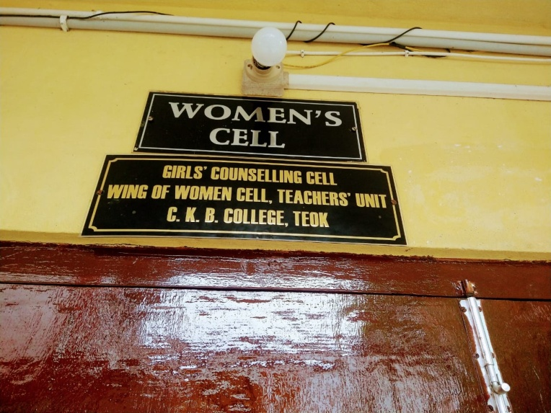  - COUNSELING ROOM
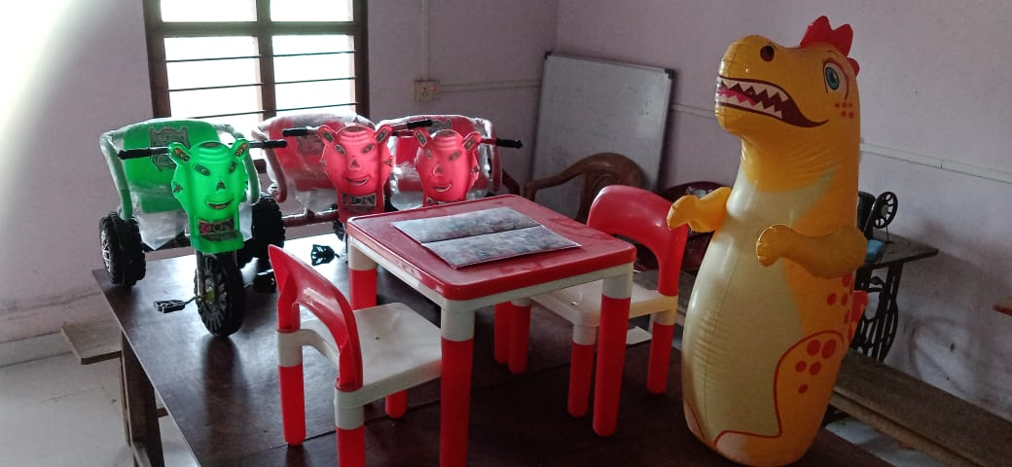  - DAY-CARE CENTRE | 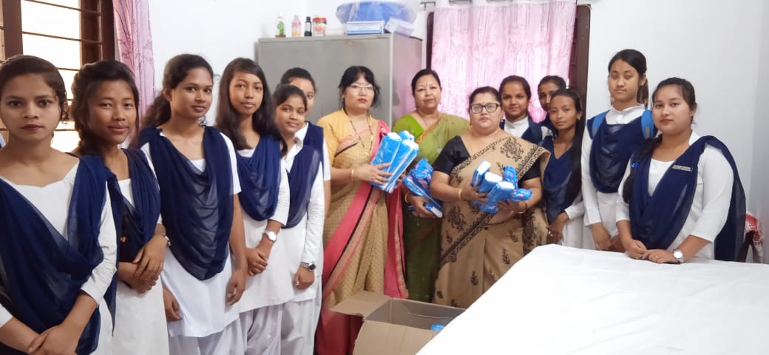  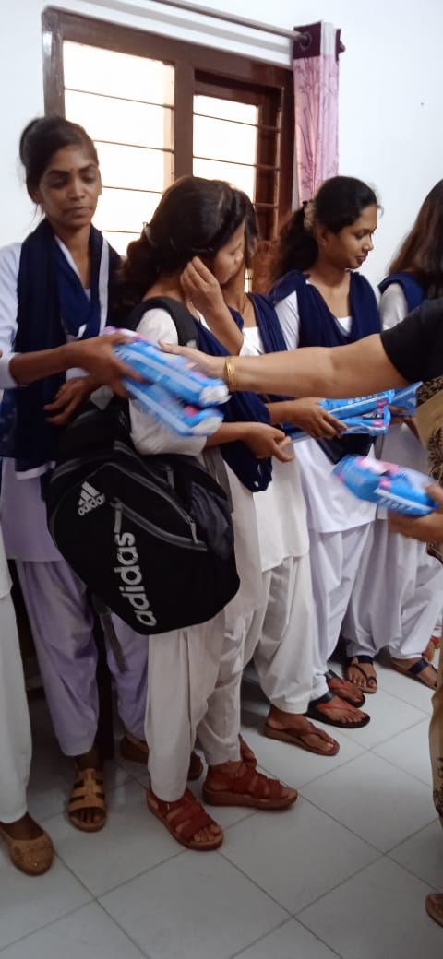  - DISTRIBUTION OF SANITARY NAPKINS TO GIRLS STUDENTS
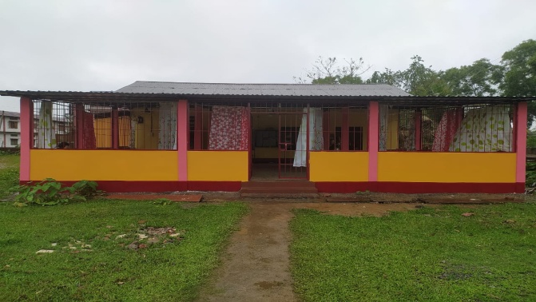  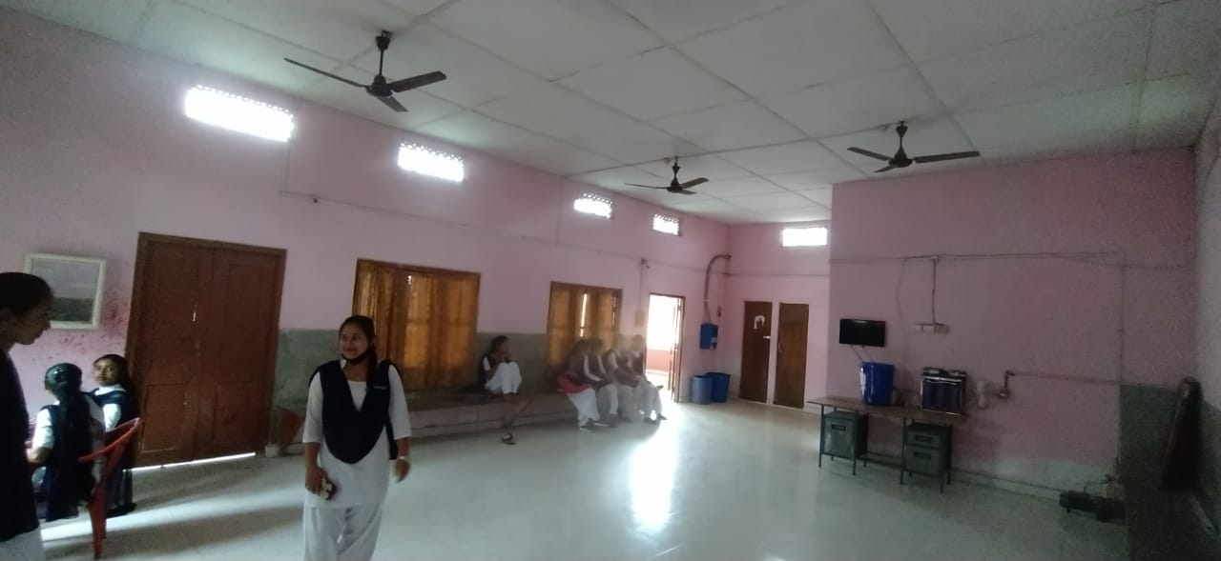  - GIRLS’ COMMON ROOM | 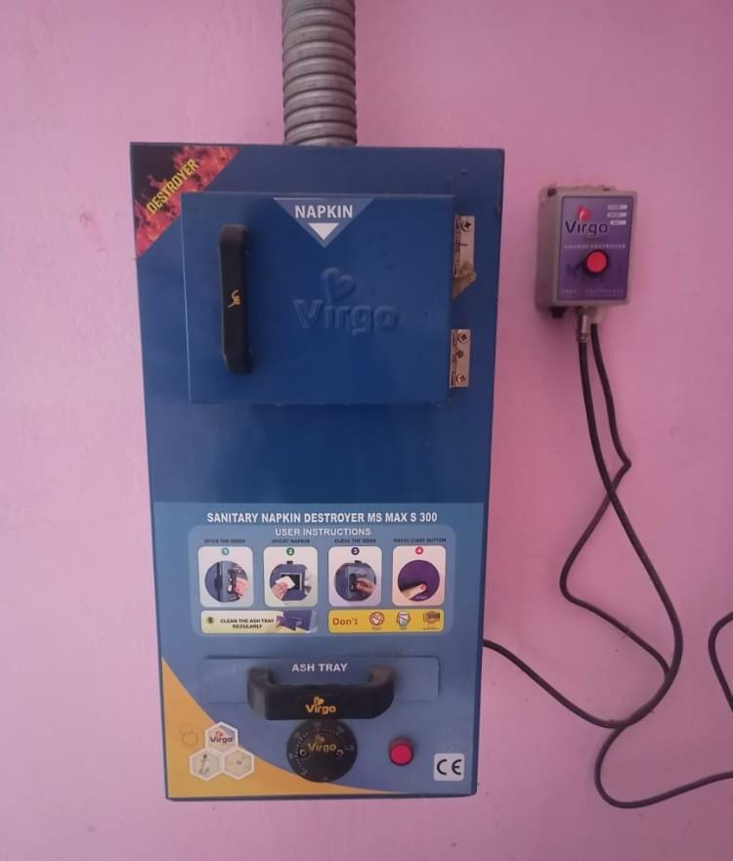  - INCINERATOR AT THE GIRLS’ COMMON ROOM

